**Week 9&10 assignment 5.2 - Charts**

**Swetha Chamala**

**Bellevue University**

I used the birth-rate.csv, crimeratesbystate-formatted.csv and education.csv data files provided in the assignments link for creating the following charts. I have also used the Iris dataset available in scikit learn datasets in Python.

**Python – charts**

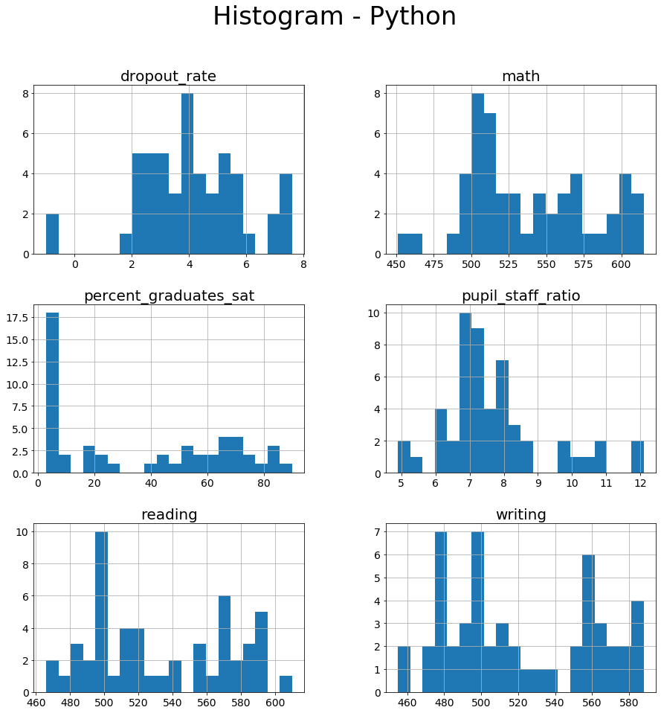

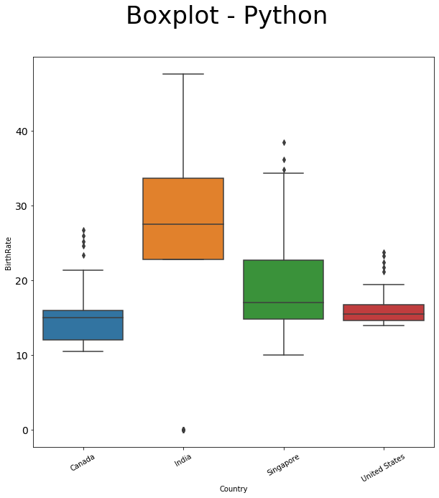

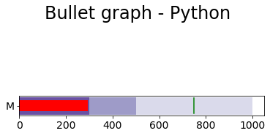

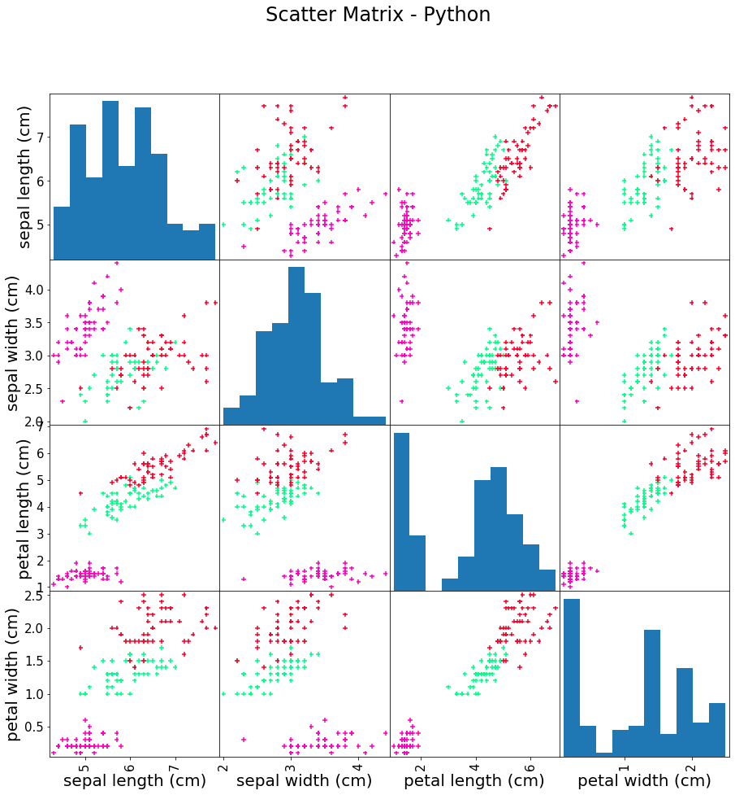

**R – charts**

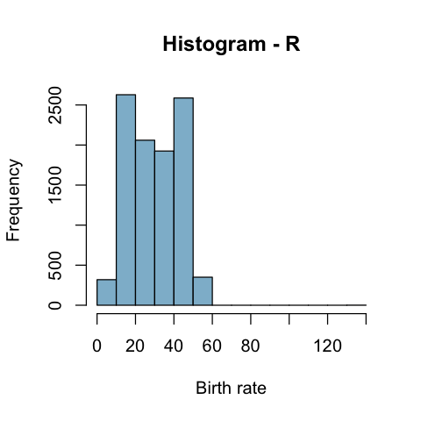

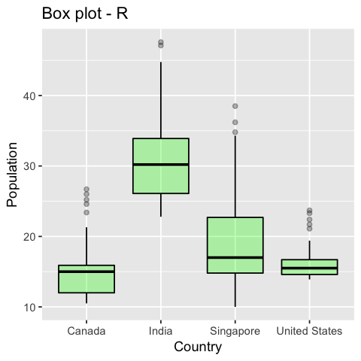

**Bullet Chart - R**

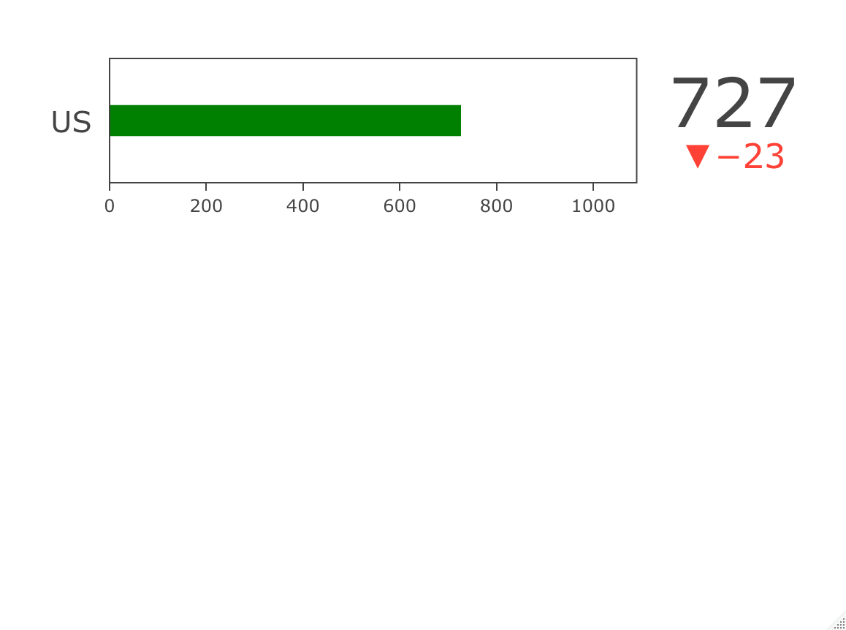

**Chernoff’s faces – R (additional chart)** – for crime rates in the US and statewise

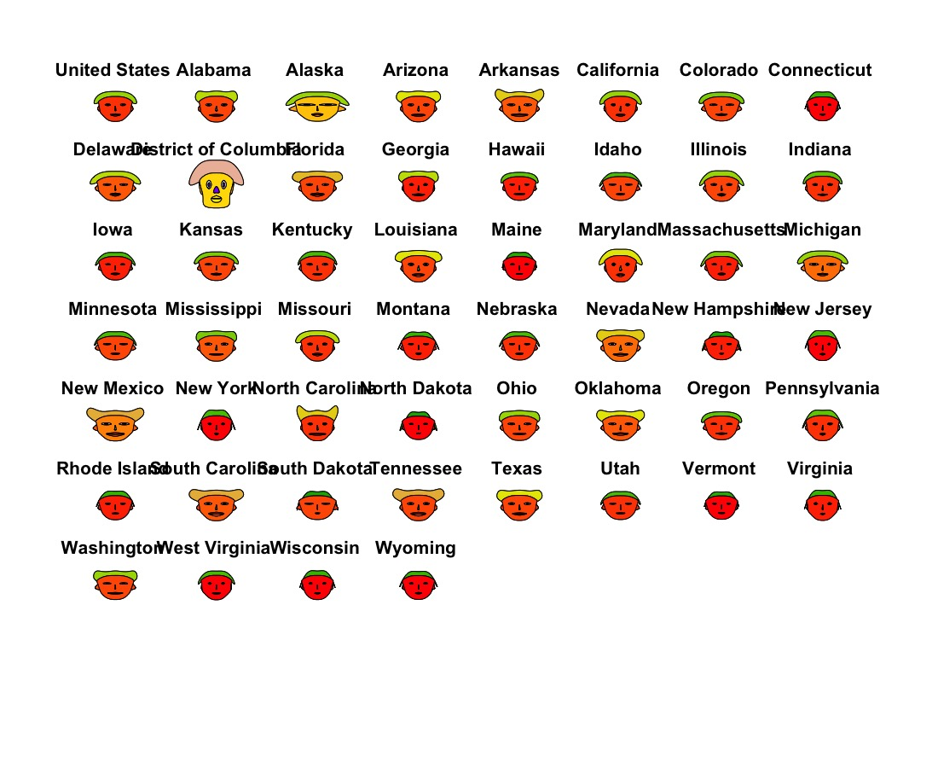

**Tableau – charts**





